Journal of Cardiovascular Aging

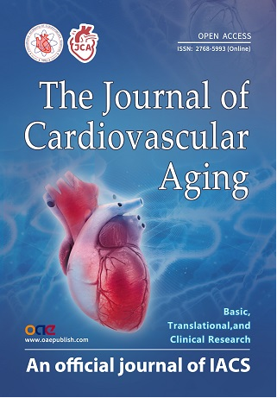


Editor:
Dr. Ali J. Marian

Editorial Office:

The Journal of Cardiovascular Aging
OAE Publishing Inc.
245 E Main Street Ste 107,
Alhambra, CA 91801, USA
Email: editorialoffice
@cardiovascularaging.com;
cardiovascularaging@gmail.com

